Randwick Village Hall Water Boiler Instructions v1 14/1/23

- Power on at wall switch. Display will light up “WAIT”.

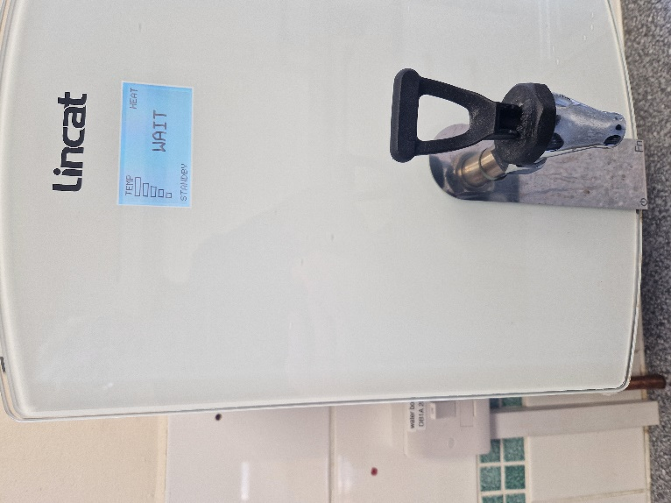
Dispense tap

- Once at temperature display shows “READY”.

3.Dispense water from tap and unit will automatically refill and reheat.

After use power off at wall switch

