Randwick Village Hall Audio Visual Equipment Instructions v1 23/1/23

The Audio Visual system comprises
- Screen
- Projector
- DVD player
- Amplifier
- Surround sound speakers
The system is primarily intended to play DVD via the DVD player however the DVD player can be substituted by a laptop and should sound only be required the amplifier can be connected to any device via Bluetooth.
In order to use the equipment access will be required to the locked cabinet in the right hand cupboard at the rear of the hall. Keys are in the key safe in the kitchen.
Using the projector equipment
- Power on the switch marked X above the control cabinet.

- Unlock the cabinet and remove the box containing the remotes.

- Direct the screen remote at the receiver behind the curtain pelmet at the front of the hall (LHS). Using the buttons on the remote adjust the screen height.
Stop
Down
Up

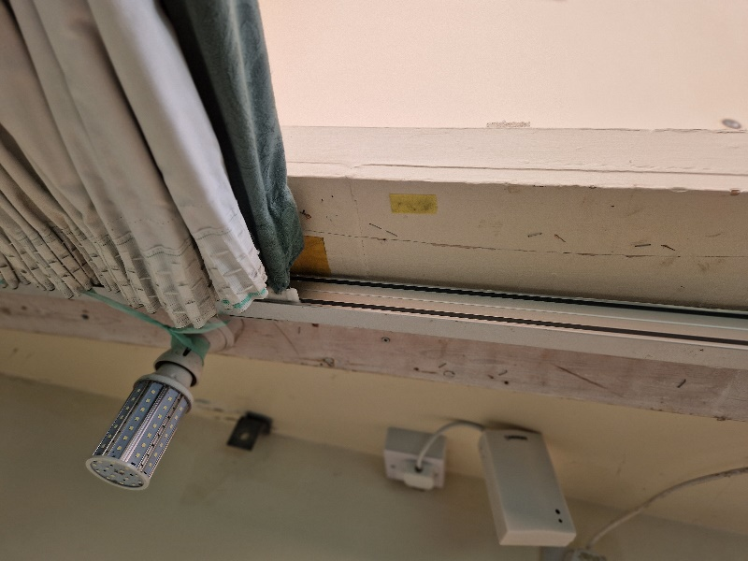
Receiver

- Turn on projector unit by selecting the blue button on the Epson remote whilst it is pointed at the projector unit.

- Take the DVD player from the cabinet and plug it into the HDMI lead behind the stage curtains at the front of the hall. Plug in the DVD unit to the power socket.
DVD player

Plug in HDMI lead

At the same time check the sub-woofer speaker is also powered on.

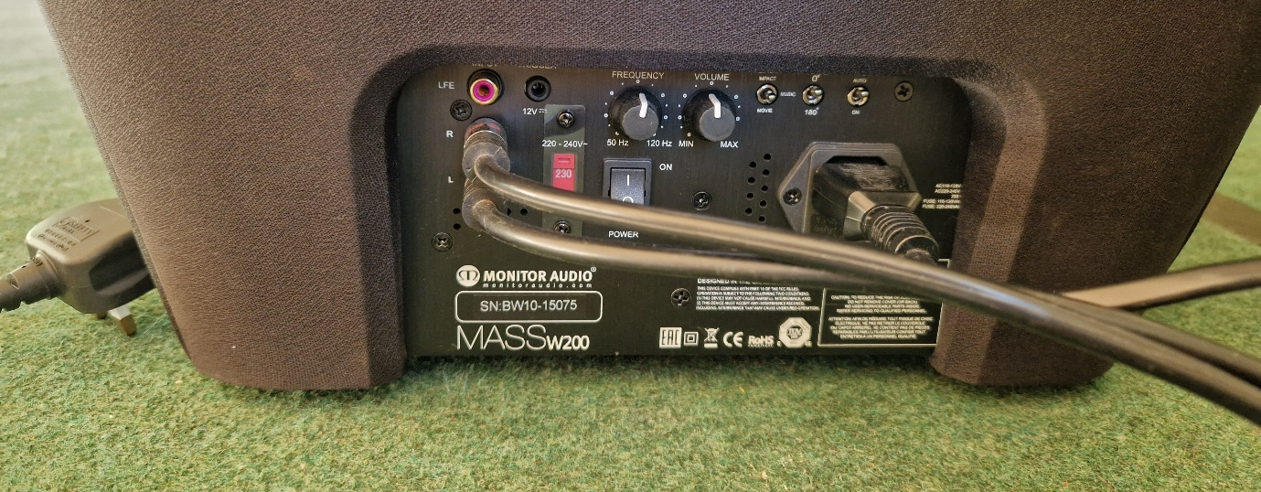
Speaker switched on
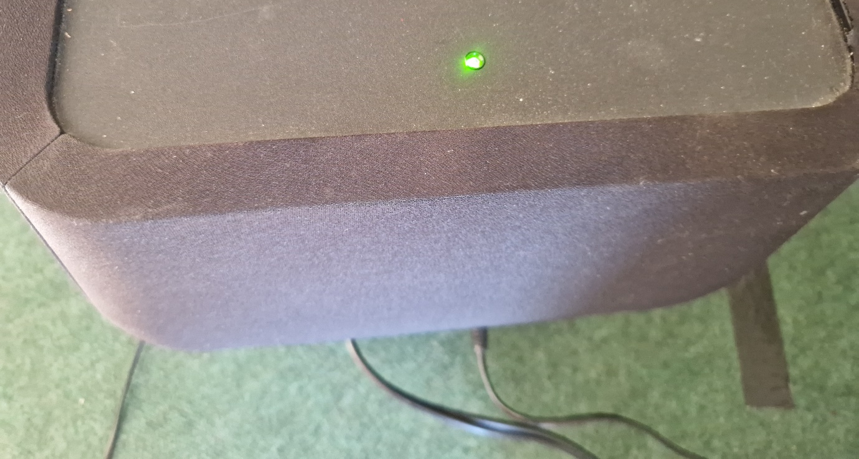
Speaker ON indicator

- Select “BD/DVD” on amplifier unit by turning the input selector dial.

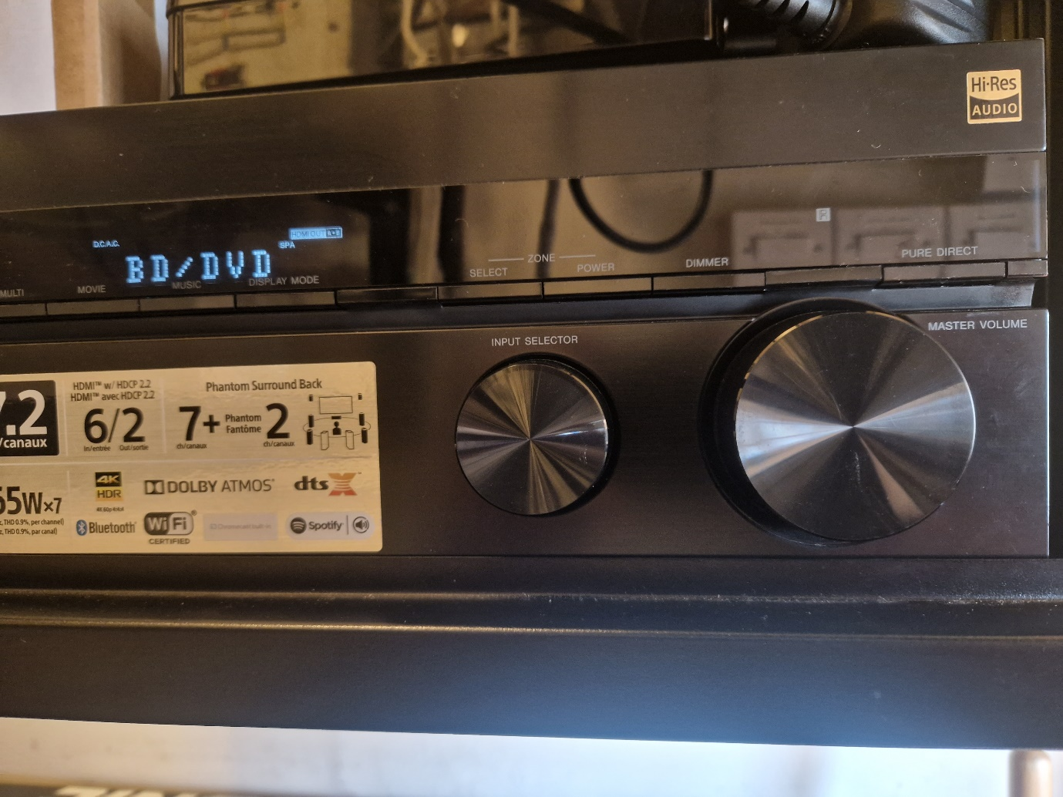

Sound can be adjusted using the other Master volume dial.

- Insert DVD into DVD player and select play on the remote.

- After use switch off all equipment and power off at master wall switch.

- To use a laptop plug the HDMI lead into the HDMI socket on the laptop rather than the DVD player. All other set up remains the same. The laptop display output may have to be configured for dual screens.

- To use the surround sound by Bluetooth the screen, projector and DVD are not required. Power on the front speaker as per 5 above. Switch on blue tooth on your device and play your sounds.

- Turn the input selector dial to “Bluetooth”.
The devices will attempt to pair. Follow any pairing instructions on your device.
